Phase 3: Import Set Table

Navigation:

In Application Navigator → Load Data

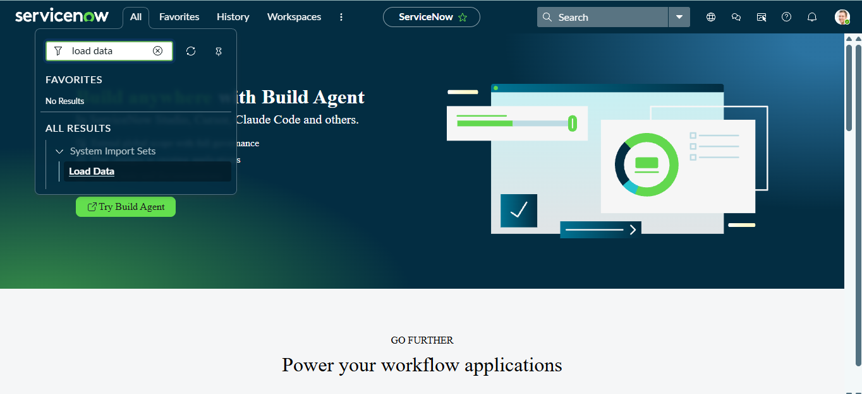

Click on Load Data and create an import table
Fill details as shown below
- Label: Employee Import

- Name: u_employee_import (auto populated)

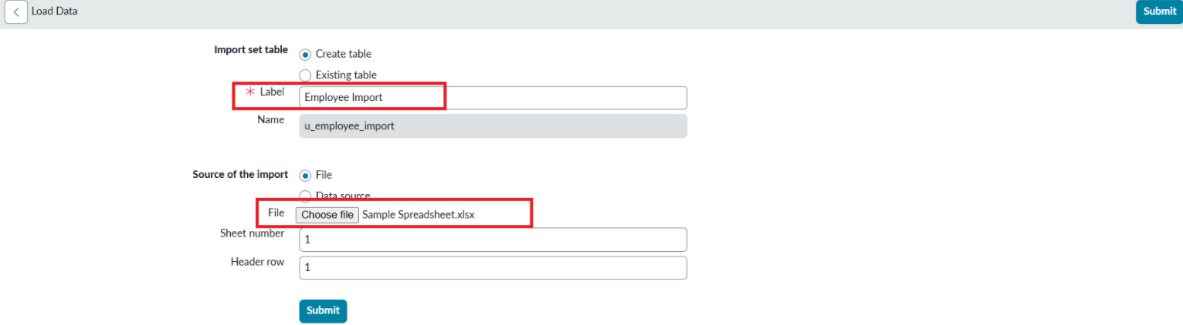
- Click on Submit

Once we click on Submit, we can see the success message as shown below.

Also we need to make sure to click on Create Transform Map.

